INTERNATIONAL SCHOOL OF
MANAGEMENT AND TECHNOLOGY

FACULTY OF COMPUTING
ASSIGNMENT COVER SHEET
This form is to be completed by students submitting assignments of level 4 and level 5. Students are required to complete all sections and attach to your assignment.

STUDENT DETAILS
STUDENT NAME
STUDENT ID | 2024IT195

UNIT AND ASSIGNMENT DETAILS
UNIT TITLE | Unit 13: Website Design &amp; Development
UNIT NUMBER | Y/618/7419
ASSIGNMENT TITLE | Radiant Memories Photography
ISSUE DATE | November 22, 2024 | DUE DATE | Feb 12, 2025
ASSESSOR NAME | Bikul Raj Koirala
ESTIMATED WORD LENGTH | 9000

SUBMISSION
HAND IN DATE | Feb 12, 2025

DECLERATION AND ACKNOWLEDGEMENT
When submitting assignments, each student must sign a declaration confirming that the work is their own.

Plagiarism and Collusion
Plagiarism: to use or pass off as one’s own, the writings or ideas of another without acknowledging or crediting the source from which the ideas are taken.
Collusion: submitting an assignment, project or report completed by another person and passing it off as one’s.
In accordance with the Academic Integrity and Plagiarism Policy:
- I declare that:
- this assignment is entirely my own work, except where I have included fully-documented references to the work of others,
- the material contained in this assignment has not previously been submitted for any other subject at the University or any other educational institution, except as otherwise permitted,
- no part of this assignment or product has been submitted by me in another (previous or current) assessment, except where appropriately referenced, and with prior permission from the Lecturer / Tutor / Unit Coordinator for this unit.

- I acknowledge that:
- if required to do so, I will provide an electronic copy of this assignment to the assessor;
- the assessor of this assignment may, for the purpose of assessing this assignment:
- reproduce this assignment and provide a copy to another member of academic staff;
- communicate a copy of this assignment to a plagiarism checking service such as Plagiarism Check (which may then retain a copy of this assignment on its database for the purpose of future plagiarism checking).

I am aware of and understand that any breaches to the Academic Code of Conduct will be investigated and sanctioned in accordance with the College Policy.
SIGNATURE |  | DATE | Feb 12, 2025

Table of Contents
1. Introduction 3
1.1. Assignment Overview 3
1.2. Objective and Scope 3
2. Technologies for Website Development and Hosting 4
2.1. Purpose and Types of DNS 4
2.2. Domain Name Organization and Management 5
2.3. Communication Protocols and Server Technologies 6
• HTTPS, FTP 6
• Server Hardware and Operating Systems 7
• Web Server Software (Apache, Tomcat, IIS, Nginx) 8
2.4. Front-end and Back-end Technologies 9
• Presentation and Application Layers 9
2.5. Online Website Creation Tools vs. Custom-Built Sites 10
- Design Flexibility, Performance, Functionality, UX, UI 10
Conclusion 11
Activity 2 11
Design and Development of the Website 11
2.1. Client and User Requirements 11
2.2. Wireframes and Interface Design 12
2.3. Networking and Hosting Considerations 26
2.4. Security Features 27
2.5. Accessibility and Inclusivity Guidelines 28
3. Implementation of a Multi-Page Website 29
3.1. Branded Multi-Page Website with Realistic Content 29
3.2. Test Plan Creation 30
3.3. Implementation of Test Plan 31
4. Quality Assurance and Evaluation 32
4.1. Web Design Principles, Standards, and Guidelines 32
4.2. Quality Assurance Process 33
4.3. Evaluation of Design and Development Process 34
4.4. Technical Challenges and Solutions 36
5. Testing and Performance Review 37
5.1. Test Plan Results 37
5.2. Recommendations for Improvement 38
References 40

Introduction

Assignment Overview
This project develops and evaluates a multi-page portfolio site for professional photography group Radiant Memories which wants to create an online platform. The system develops an online platform which presents professional presentations of work and skills alongside accomplished achievements. The task includes various subtasks that start with a review of essential server systems alongside communication standards and web development instruments needed to operate and maintain websites. Users need to understand how custom-coded websites differ from online website builders because of their varying potential to adapt designs and execute functions and their resulting performance and user satisfaction (UX). The second task entails developing a branded multi-page website by applying client demands through the creation of wireframes and by implementing security features and accessibility standards while managing networking and hosting aspects. The final stage of website development creates a thorough test plan which examines website functionality alongside performance then evaluates both QA procedures and final project assessment including future growth recommendations.

Objective and Scope
Objective
The primary goal of this work is to design and build a professional multi-page portfolio web platform for Radiant Memories which strives to achieve online exposure as a photography team. Through this website Radiant Memories intends to display their photography work together with their skills and accomplishments. Potential clients can browse the portfolio from this platform to initiate either inquiries or make bookings or establish collaboration contacts. The project will use contemporary web development frameworks and adopt standard practices for design standards and functional design along with security measures. The website will contain an administrative section to control and interact with website content and client messages easily.
Scope
This assignment task includes full development work on creating a branded website with multiple pages. This includes:
- Requirement Analysis: The initial step involves obtaining both user and client requirements so the website can fulfill their needs during Requirement Analysis.
- Design and Development: The development team creates wireframes and interface designs which they implement into a secure accessible website.
- Technology and Tools: The website development relies on current server solutions alongside communication protocols with suitable web development tools that create an easily usable platform.
- Testing and Quality Assurance: A test plan development process will be created for checking website functionality and performance and design quality.
- Evaluation and Recommendations: Among our tasks is to assess the entire development process through identifying difficulties as well as creating recommendations for future projects.

Technologies for Website Development and Hosting
Website functionality together with security and usability depends on integrating multiple technological services which make websites operational and reachable to users. Front-end and back-end frameworks and communication protocols together with server hardware and operating systems and web server software are included in these technologies. Hosting solutions offer internet users storage space for their files as well as the mechanisms needed to access these files through the web (MD, 2001). The selection of appropriate technologies remains vital because it determines maximum website functionality together with scalability while ensuring optimal user experience.

Purpose and Types of DNS
Introduction
Users benefit from Domain Name System (DNS) because it converts accessible domain names into IP addresses to help them quickly navigate websites. This network component operates as the address directory for internet addresses to facilitate device communication. DNS contains multiple server types which include recursive DNS servers and authoritative servers and root servers and top-level domain servers and caching servers that fulfil separate duties during domain resolution.
Purpose of DNS
The internet relies on the Domain Name System (DNS) to perform its vital role as a distributed directory for transforming easy-to-read domain names (www.example.com) into computer-friendly IP addresses (192.168.1.1). Users can reach websites through easy-to-remember domain names instead of numeric IP addresses through this translation process. Through DNS users can establish smooth communication with servers that maintains internet efficiency. The system serves three main functions by translating domain names into IP addresses and making the internet both faster and more expandable while protecting against network failures because it operates as a decentralized directory (Marrison, 2015).

Types of DNS
- Recursive DNS Servers: The servers work through user requests while probing various DNS servers to locate the necessary data until they find the required outcome. The servers serve as a communication link that connects users to authoritative servers.
- Authoritative DNS Servers: Domain name queries are answered definitively by these servers which maintain stored records. The servers maintain real DNS records which include A, CNAME, MX and NS records that pertain to their managed domains (Yanan & Zhaoxin, 2023).
- Root DNS Servers: The top-level DNS servers known as root servers serve to resolve requests which target root zone records (Rizvi, 2023). A query proceeds to the right top-level domain (TLD) server which can be .com or .org patches.
- Top-Level Domain (TLD) Servers: The server’s function to handle domain data that relates to particular TLDs such as .com, .net and .org. When a request arrives, the DNS directs it to the authoritative server managing the specified domain.
- Caching DNS Servers: These DNS servers act as short-term storage for DNS query information to minimize response times when users requery the domain names. These servers enhance domain resolution efficiency because they minimize repeated queries through their fast response time.

Domain Name Organization and Management
Introduction
A hierarchy of domains starts with the root zone followed by top-level domains (TLDs) and continues with second-level domains (SLDs) while subdomains form the lower part of this structure. This organizational system enables practical website identification along with management tasks (Bonastre, 2019). Domain management requires taking care of domain registrations and configuring DNS systems along with domain renewals and security measures installation to guarantee website accessibility and shield systems from cyber threats.
Domain Name Organization
- Root Level: The root level functions as the highest domain name hierarchy position which uses a single dot to distinguish itself. The starting position for domain name searching processes begins at this level.
- Top-Level Domains (TLDs): TLDs appear directly below the root level as generic TLDs (gTLDs) with options like .com and .org and .net and country-code TLDs (ccTLDs) such .uk and .jp and .np.
- Second-Level Domains (SLDs): Users select the main domain name that appears in direct relationship to Top-Level Domains at a level called Second-Level Domains (SLDs) (Antonini Macedo, 2000). An example of this is "example" within example.com.
- Subdomains: Site management through subdomains allows administrators to establish different website sections using optional extensions added to the second-level domain name (blog.example.com provides an example case).

Domain Name Management
Two primary responsibilities of domain management include maintaining availability beside protecting security and proper functionality.

- Domain Registration: Domain registrars provide accredited domain registration services for acquiring specified domain names that last for particular timeframes (Coull, 2012).
- DNS Configuration: DNS records including A CNAME and MX and TXT types need to be configured for proper domain traffic direction and operational functionality.
- Renewal and Expiration Management: An organization needs to monitor domain expiration dates through Renewal and Expiration Management to prevent service disruption by renewing them promptly.

Communication Protocols and Server Technologies
Web servers require communication protocols together with server technologies to enable data exchanges with their clients. The protocols determine communication rules which secure dependable data transfer operations (Cüneyt Bayılmış, 2022). Web development commonly relies on HTTPS together with FTP as the primary protocols for operation.

HTTPS, FTP
HTTPS (Hypertext Transfer Protocol Secure):
The internet communication protocol HTTP receives its security enhancements through HTTPS when enabling protected end-to-end data exchange. Encryption through the TLS (Transport Layer Security) or SSL (Secure Sockets Layer) protocols safeguards all data between clients and servers to protect it from unauthorized monitoring.
- Purpose: Ensures data security and user privacy.
- Key Features: Three fundamental aspects of this protocol include encryption as well as authentication together with data integrity.
- Use Case: The website employs the Online transactions, user authentication and secure communication protocols.

FTP (File Transfer Protocol):
The File Transfer Protocol enables standard operations for file movements between computers which exist as client machines and servers through networks (Morgan, 2019). Users rely on FTP for file transfer operations when they need to upload and download server contents.
- Purpose: Facilitates file transfer and management.
- Key Features: This system enables users to manage file uploads together with file downloads and performs directory operations.
- Use Case: The Website content management system alongside file backup solutions and software distribution functions as the Use Case.

Server Hardware and Operating Systems
Server Hardware
The physical equipment which delivers vital processing possibilities and data storage and networking features to operate websites as servers constitutes server hardware. Reliable server hardware with high performance levels stands essential for websites to perform at top capacities and stay available throughout operation (Anon., n.d.). Server hardware consists of three crucial elements which are:
- Central Processing Unit (CPU): The Central Processing Unit (CPU) performs both instruction processing while managing simultaneous requests to handle multiple requests at once. A website must contain performance-oriented CPUs to deal with sudden spikes in user traffic.
- Memory (RAM): The memory functions as a temporary storage system which accelerates server speed while boosting performance. Server speed at the same time improves through additional Random-Access Memory storage.
- Storage Devices: Server applications require storage devices that act as a database for web data and hold application files and database information. Server systems nowadays implement SSD (Solid-State Drives) as their storage solution to offer both speedy operation and dependable performance.
- Network Interface Card (NIC): The Network Interface Card (NIC) serves as server connectivity to networks thus enabling communications between devices and the internet connection.

Operating Systems (OS)
An operating system functions as the controlling element for server equipment while offering programmers a platform to execute web server applications and programs (Renesse, 1985). A server operates through two primary types of operating systems that form its foundations.
- Linux-Based Operating Systems:
- Web hosting requirements make this system one of the most frequently used solutions.
- Popular distributions: Ubuntu Server, CentOS, Debian, Red Hat Enterprise Linux (RHEL).
- Advantages: Open-source, high security, stability, and extensive community support.
- Use Case: Server users should choose this operating system to run Apache, Nginx and Node.js websites.
- Windows Server:
- Microsoft developed this server software to work with Internet Information Services (IIS).
- Advantages: The Microsoft products ASP.NET combine effortlessly with SQL Server as well as Active Directory through seamless integration.
- Use Case: The Best Use Case for websites that need Microsoft technology support exists with this platform.

Web Server Software (Apache, Tomcat, IIS, Nginx)
Web server software operates by processing client demands and presenting web contents and maintaining user-server interactions. Web server programs carry distinct functional elements that let them serve different website development requirements (Vaidyanathan, 2006). Numerous web server solutions exist for global usage as described below:

- Apache HTTP Server
- Description: One of the most common and broadly used web servers in the market today is Apache. This web server solution exists as open-source software which can be modified freely through its extensive set of modules.
- Key Features: The backbone of its system includes broad compatibility with different systems and modules designed for improved protection together with detailed educational resources.
- Use Case: Web sites that require dynamic functionality through PHP Perl and Python programming benefit from Use Case.
- Tomcat Server
- Description: The Apache Software Foundation created Tomcat Server as an open-source web application platform which specifically targets the implementation of Java-based programs.
- Key Features: This server platform enables Java Servlet and Java Server Pages functionality and operates at relatively low memory consumption rates with established connections to different Apache development projects.
- Use Case: The Best use case for Java-based web applications exists with Tomcat Server.
- Microsoft IIS (Internet Information Services)
- Description: The Microsoft-developed web server IIS operates as a Windows Server integrated solution. IIS facilities deployment of Microsoft technologies by running ASP.NET together with .NET Core versions.
- Key Features: GUI configuration is simple while security features and Windows integration stand out among its main characteristics.
- Use Case: The organization finds this tool ideal when Microsoft products serve as the foundation for its web hosting needs.
- Nginx
- Description: The web server Nginx works at a high level to deliver reliable speed alongside full scalability and operational efficiency. The server acts as a reverse proxy and provides mail proxy capabilities together with its load balancing functionality.
- Key Features: The main characteristics of this system include asynchronous operation with built-in load balancing and resource-efficient design.
- Use Case: Nginx demonstrates its peak performance by supporting websites with heavy traffic that need instant response speed together with scalability.

Front-end and Back-end Technologies

Presentation and Application Layers
A functioning interactive website results from combining front-end and back-end technologies specifically developed for web development. Web technologies classify into two essential solution levels which map to Presentation Layer and Application Layer respectively (Offutt, 2009).

Presentation Layer (Front-End Technologies)
Website users interact with the visual components that belong to the presentation layer where they can find all user interface elements. Web pages receive their structure through design and also obtain their behavior from this level of focus. Key front-end technologies include:
- HTML (Hypertext Markup Language): Defines the structure and content of web pages.
- CSS (Cascading Style Sheets): The presentation and layout of web elements comes under CSS (Cascading Style Sheets) programming.
- JavaScript: Adds interactivity and dynamic content to web pages.
- Frameworks and Libraries: The development efficiency and functionality improve when developers use React, Angular, Vue.js along with frameworks and libraries.
Application Layer (Back-End Technologies)
The server-side logic along with database connections and business procedures operate through the application layer. The system handles data processing duties to send information to the front-end presentation layer. Key back-end technologies include:
- Programming Languages: The application uses Node.js (JavaScript) together with Python and PHP and Ruby and Java as its programming languages.
- Web Servers: Apache, Nginx, IIS, and Tomcat.
- Databases: MySQL, PostgreSQL, MongoDB, and SQLite for data storage and management.
- Frameworks: Express.js (Node.js), Django (Python), Laravel (PHP), and Spring (Java).

Integration between Front-End and Back-End
The front and back sides of a system require complete coordination to produce a unified user experience. The front-end engages with the back-end through APIs to retrieve processed results that will be displayed to users on the interface (Artto, 2016).

Online Website Creation Tools vs. Custom-Built Sites

Design Flexibility, Performance, Functionality, UX, UI
Website building demands a critical decision point between designing custom-built sites and using online website creation tools. These approaches offer different strengths and constraints that apply to website design flexibility, performance capabilities and functionalities, together with UX and UI quality.

Online Website Creation Tools
Such platforms work as ready-made solutions which let users develop websites while skipping coding expertise. Some popular providers of this service are Wix and Squarespace along with WordPress.com.
- Design Flexibility: Users enjoy restricted design capabilities with online website creators compared to bespoke site development approaches. The user experience is limited to select designs from basic templates and layout options.
- Performance: Website performance depends on the hosting environment that the platform furnishes to its users.
- Functionality: Basic functionality is simple to use yet complex customization needs premium plugins or premium features.
- User Experience (UX): Simplified tools provide users with a consistent experience yet do not allow personalization during the process.
- User Interface (UI): The system provides contemporary presentation templates together with restricted design modification capabilities.

Custom-Built Sites
Developers who start from scratch to build websites by merging front-end with back-end technologies gain full design and functionality control.
- Design Flexibility: The capability to build special designs with whole control over appearance exists through developer access to customer-specific needs.
- Performance: The speed and scalability performance depends on the selected technology stack in the development process.
- Functionality: Supports complex features and integrations. The implementation of custom-made solutions allows developers to fulfill particular demands.
- User Experience (UX): Businesses have full power to customize User Experience (UX) frameworks according to their target group so they can create more usable interfaces with enhanced user engagement.
- User Interface: The User Interface component enables full customization of appearance to match brand design specifications.

Conclusion
The multi-page website delivered to Radiant Memories passed all client requirements through its implementation of current web technologies in combination with security features and accessibility standards. Detailed documents about design including wireframes combined with user requirements helped create an orderly development process that was efficient. A complete test plan assessed the website’s performance by identifying and solving both performance-based and functional-based elements. The client now has a branded responsive multi-page website that provides user-friendly services for showcasing their portfolio and obtaining potential clients. Quality assurance together with continuous improvements resolved the development obstacles which included optimizing for different devices and achieving full browser compatibility. The project achievement implements best practices of web development which created a secure platform alongside scalability and attractive presentation that reflects the client's goals.

Activity 2

Design and Development of the Website
The design and development process for the Radiant Memories website aims to create a platform that is structured, visually attractive, and fully functional, fulfilling both client and user needs. This stage involves gathering requirements, designing the site's layout, implementing engaging features, and ensuring accessibility along with security measures. Essential factors consist of responsive design principles, quick loading times, and an intuitive user interface (Bridges, 2014). By leveraging contemporary web technologies and industry best practices, this website intends to deliver a smooth browsing experience while effectively highlighting the photographer’s portfolio.

Client and User Requirements

Client Requirements
The main goal for Radiant Memories is to cultivate a professional online presence that prominently showcases their photography work, skills, and accomplishments. The website should be aesthetically appealing, easy to navigate, and capable of drawing in potential clients. Key client specifications include:
- Portfolio Page: A visual gallery presenting high-quality images from past and ongoing photography projects.
- Experience and Skills Section: A specific area dedicated to outlining the photographer's expertise as well as any awards or recognition received.
- Contact Information: Either a contact form or direct details enabling prospective clients to make inquiries or bookings.
- Admin Dashboard: A secure backend system for managing portfolio content updates alongside client communications.
- Security and Performance: Implementation of SSL encryption (HTTPS), optimized loading speeds, and mobile-friendly responsiveness.

User Requirements
The website must offer an engaging experience for visitors by making information easily accessible and interactive. The critical user requirements are:
- Intuitive Navigation: An easily understandable layout allowing users quick access to information.
- Mobile Compatibility: Ensuring full functionality across various devices such as smartphones, tablets, and computers.
- Quick Load Time: Enhanced performance aimed at preventing delays during loading phases which could disrupt user engagement.
- Accessibility Features: Adherence to web accessibility standards ensuring useability for individuals with disabilities.
- Interactive Elements: Incorporation of elements like image sliders and filtering options and effects to enhance engagement.

Wireframes and Interface Design
Wireframes
Wireframes are vital in the internet design process as they set up the visual outline of the elements of a web page. They specify where certain elements like navigation bars, content sections, images, and call-to-action buttons would be placed. Low-fidelity (but still interested) wireframes for the Radiant Memories website were developed, providing an easy-to-use, intuitive layout, with special attention to user-friendliness and responsiveness across devices (Varley, 2010).
Low-Fidelity Wireframes: outlines basic structure and layout with no detail on design.
Medium-Fidelity Wireframes: It has a bit more detail, showing content hierarchy and any interactive elements like buttons and image sliders.
Interface Design:
A design that developed the wireframe into a visually rich web page is that of Radiant Memories. The design shows a clean and professional image while providing a convenient user experience.
Key focuses of the interface design include:
- Color Scheme: Clean and minimal colors so that no distraction is found while viewing photography.
- Typography: Modern, readable fonts should be used in all places to retain professionalism and reading convenience.
- Navigation: A clean menu structure where everything is easily accessible.
- Responsive Design: To make sure the website runs seamlessly on desktops, tablets, and mobile devices.
- Interactive Features: Features such as image hover effects, animated transitions, and sliders captivate users more.

Conclusion
The joint use of wireframes and a carefully thought-out interface design provides a useful starting point for the website development. They ensure that what the end product will deliver will be one that is beautifully presented, functional, and compatible with the client's concept and user expectation.

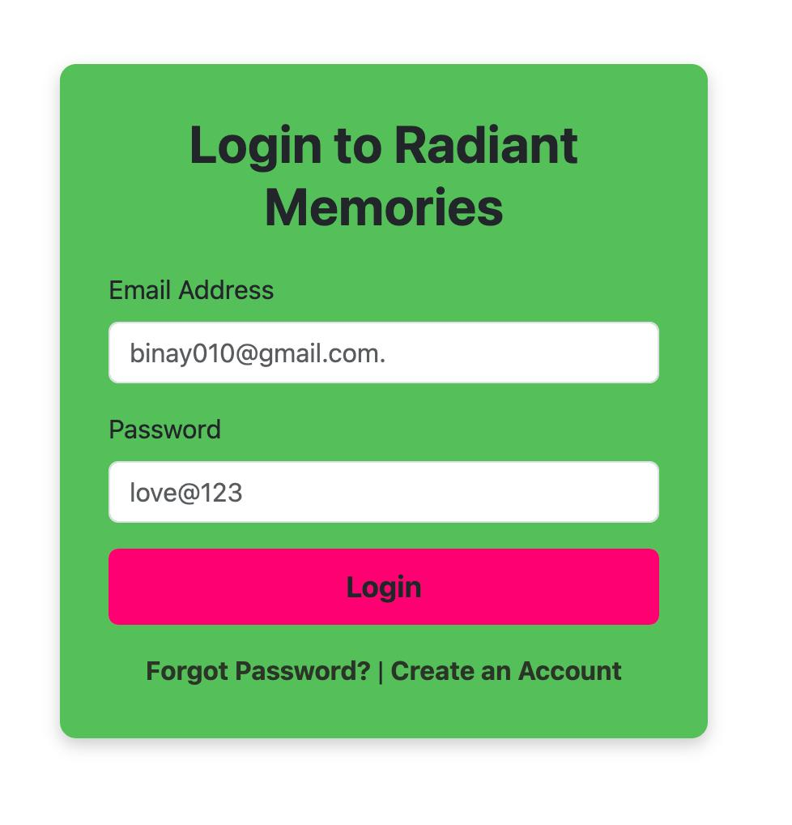
- Login page
Code Snipped of cPanel:
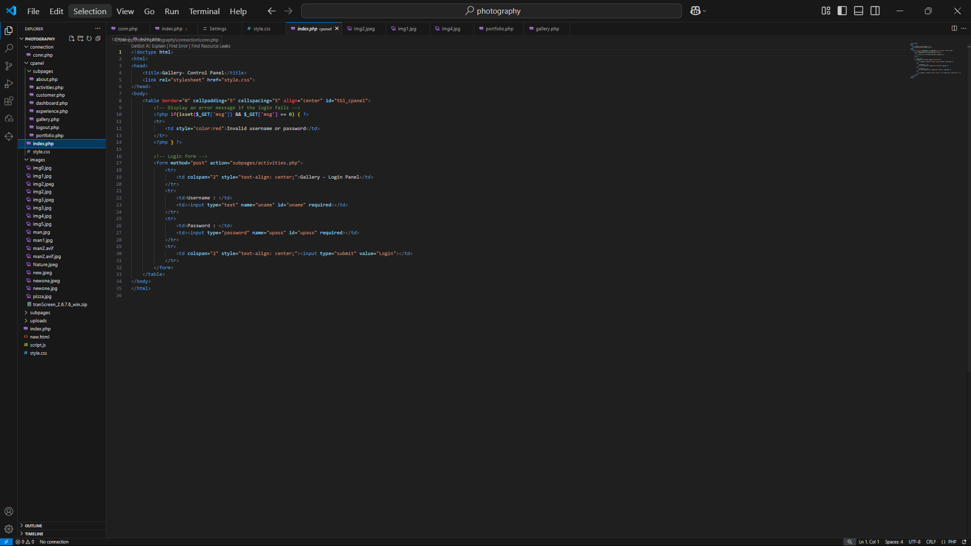
Figure 2: Code snipped of Login page.

- Index Page: 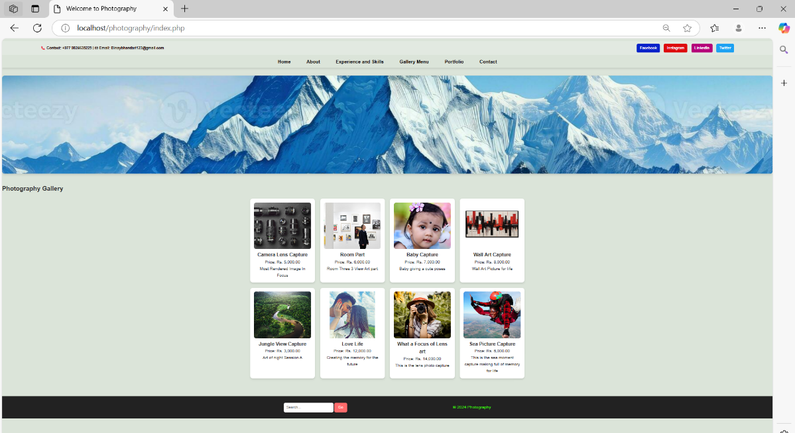
Figure 3: Index page.
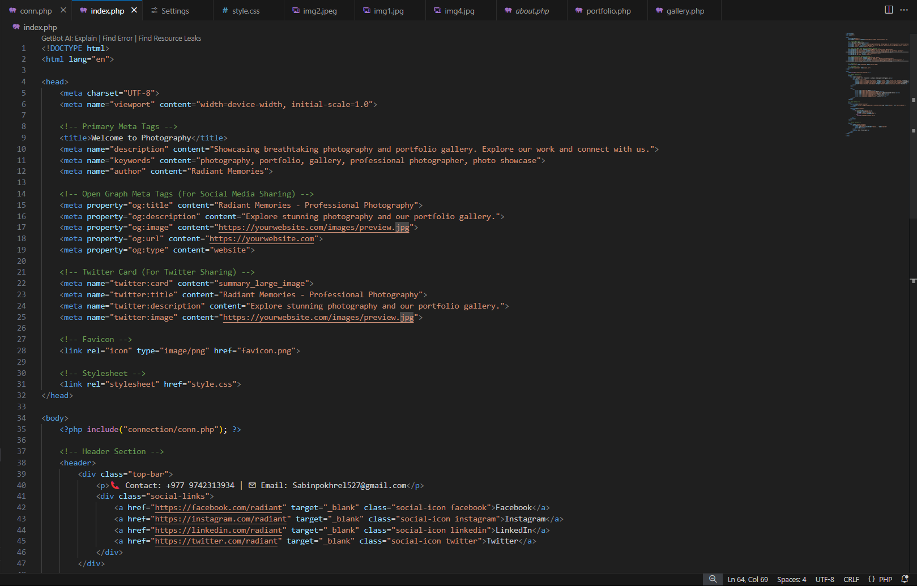
Code snipping:

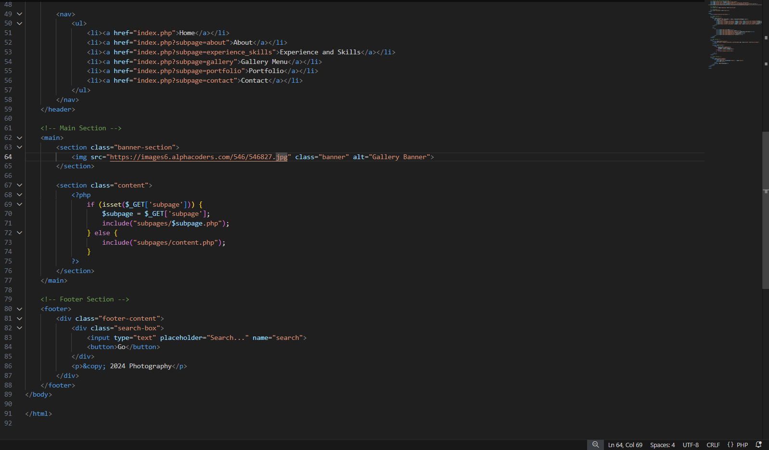
Figure 4: Code Snipped of Index page.
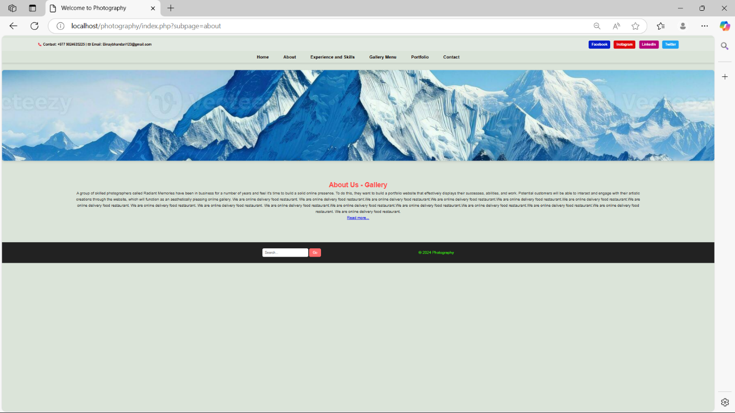
- About Page:
Figure 5: About Page.

Code Snipped of About page:
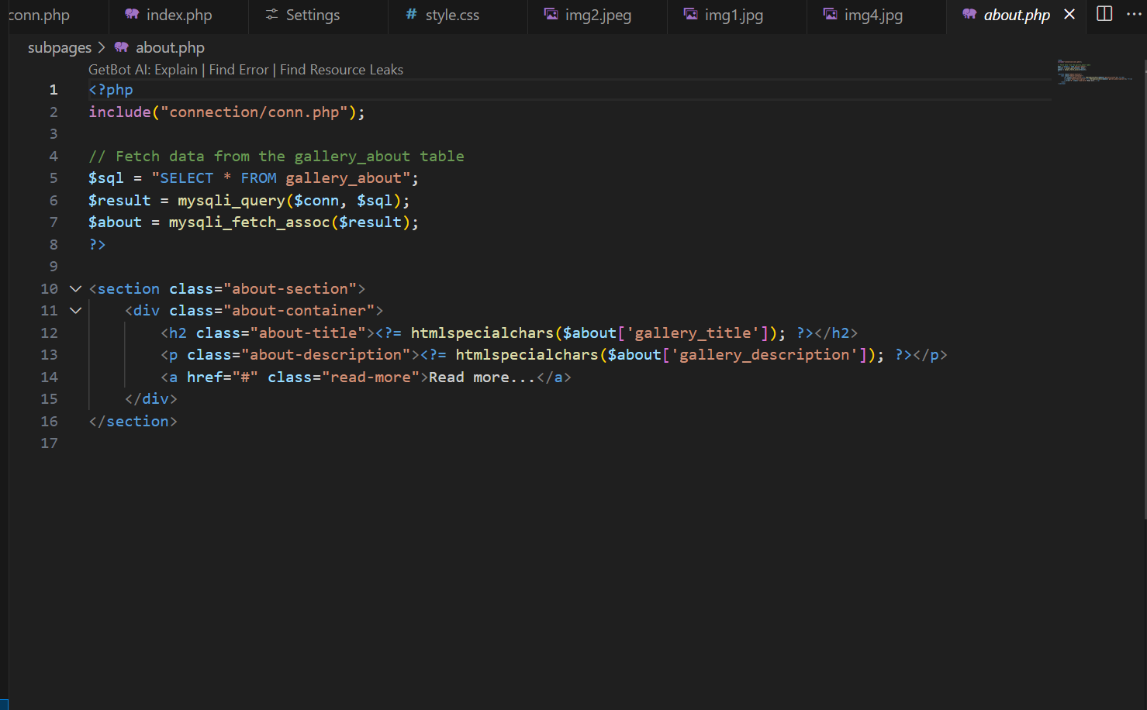
Figure 6: Code Snipped of About Page.
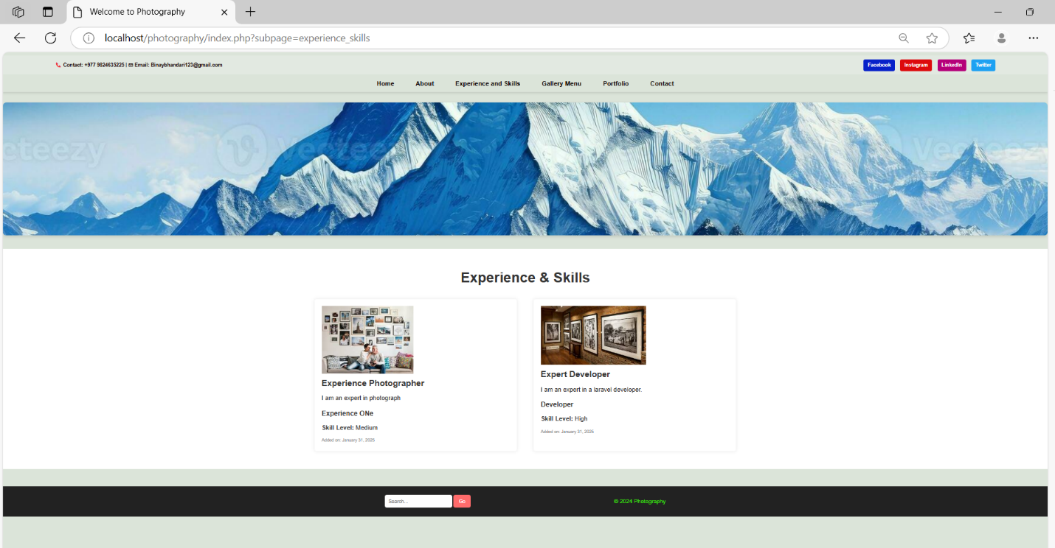
- Experience and Skills Page.
Figure 7: Experience and Skills Page.

Code Snipped of Experience and Skills Page:
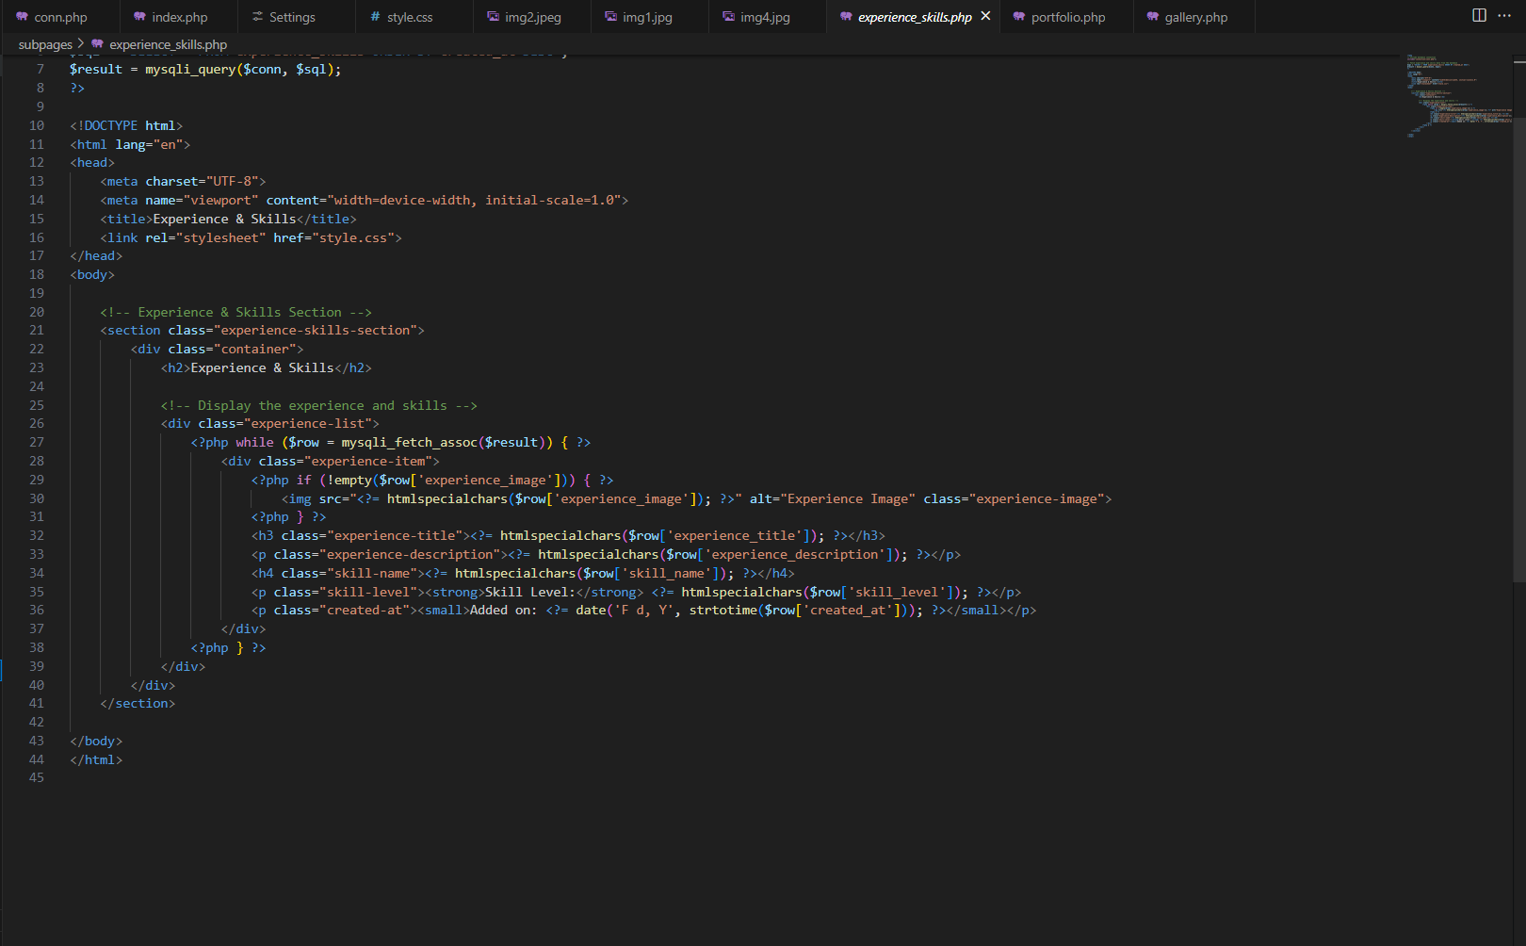
Figure 8: Code Sniped of Experience and Skills Page.
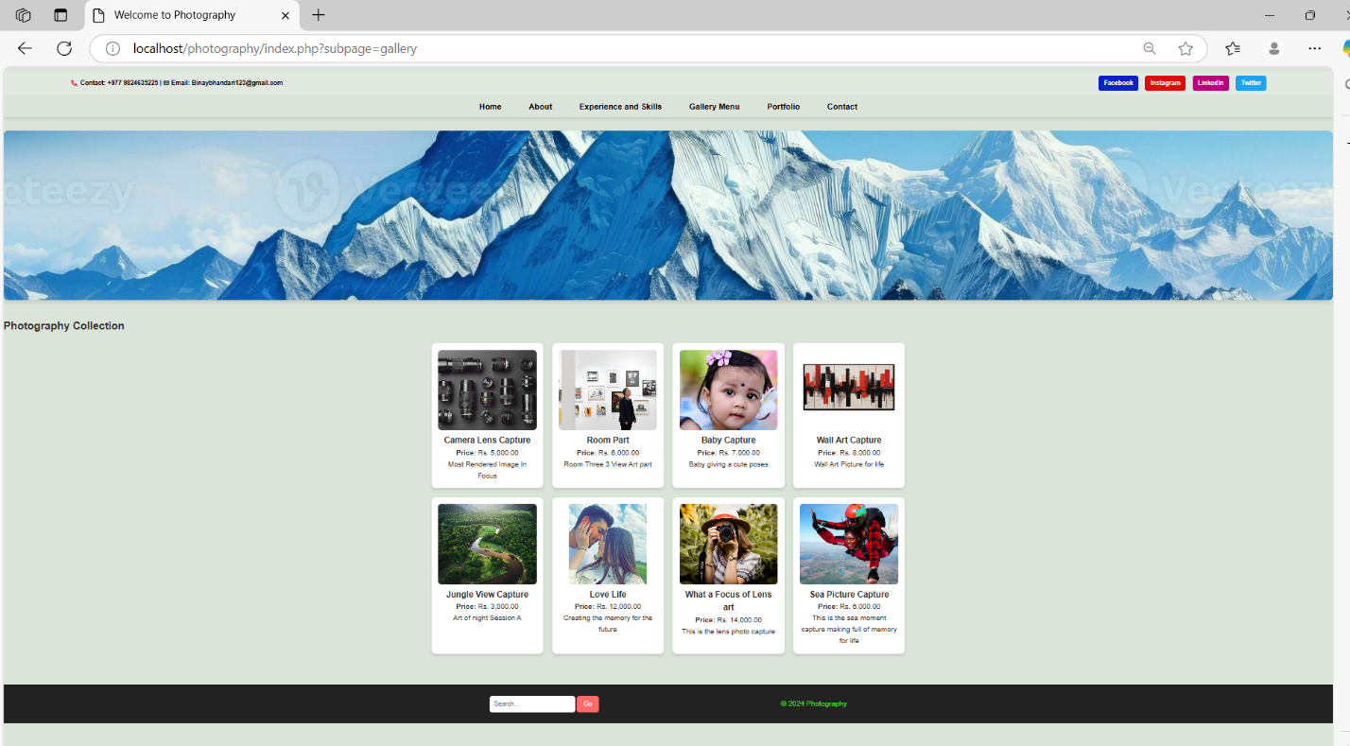
- Gallery page:
Figure 9: Gallery page.
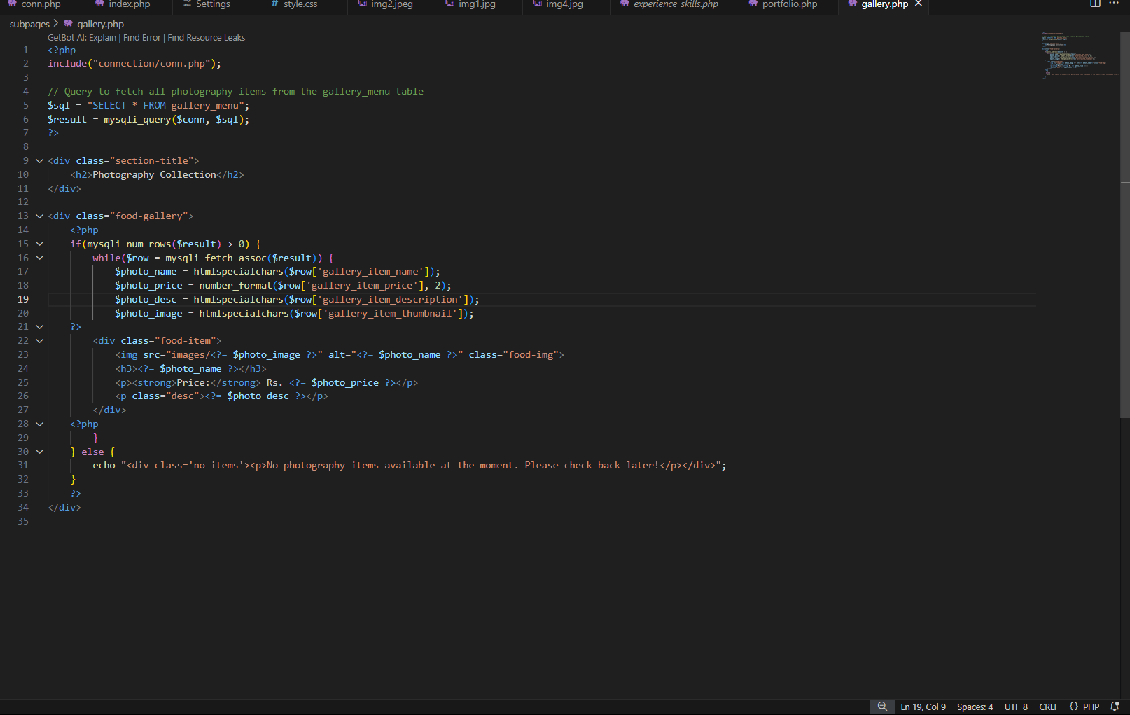
Code snipped of Gallery page:
Figure 10: Code snipped of Gallery page.

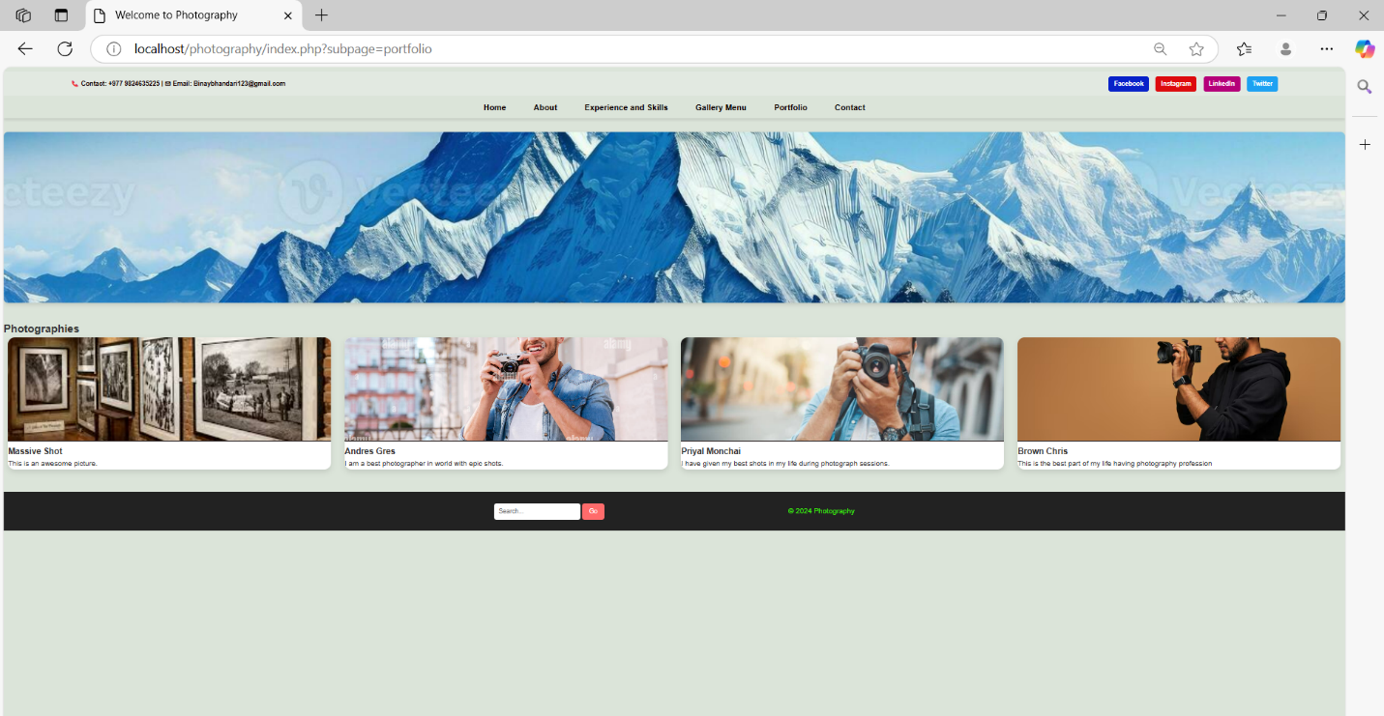
- Portfolio Page:
Figure 11: Portfolio Page.
Code snipped of Portfolio page:
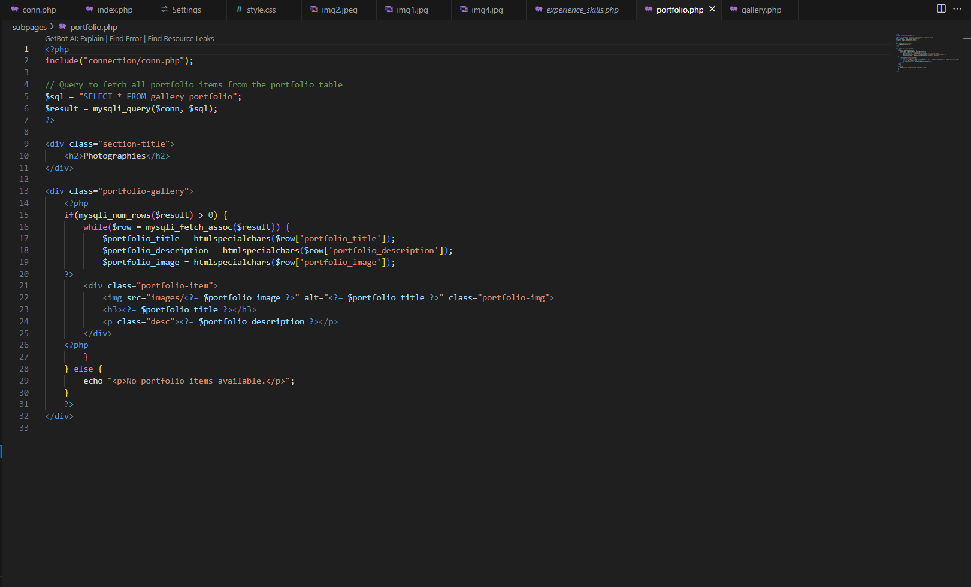
Figure 12: Code snipped of Portfolio page.

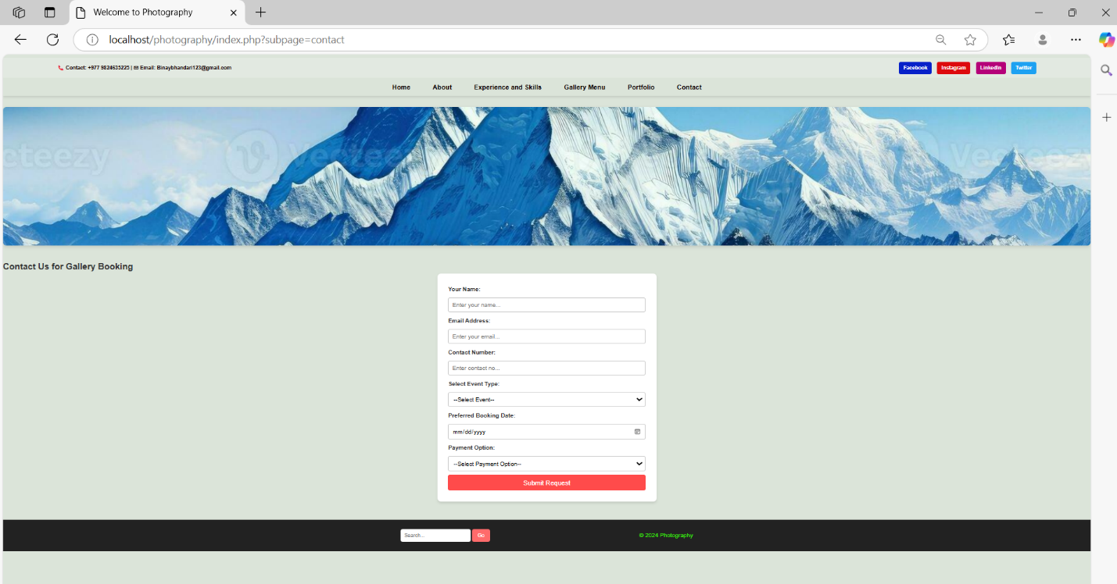
- Contact page:
Figure 13: Contact Page.
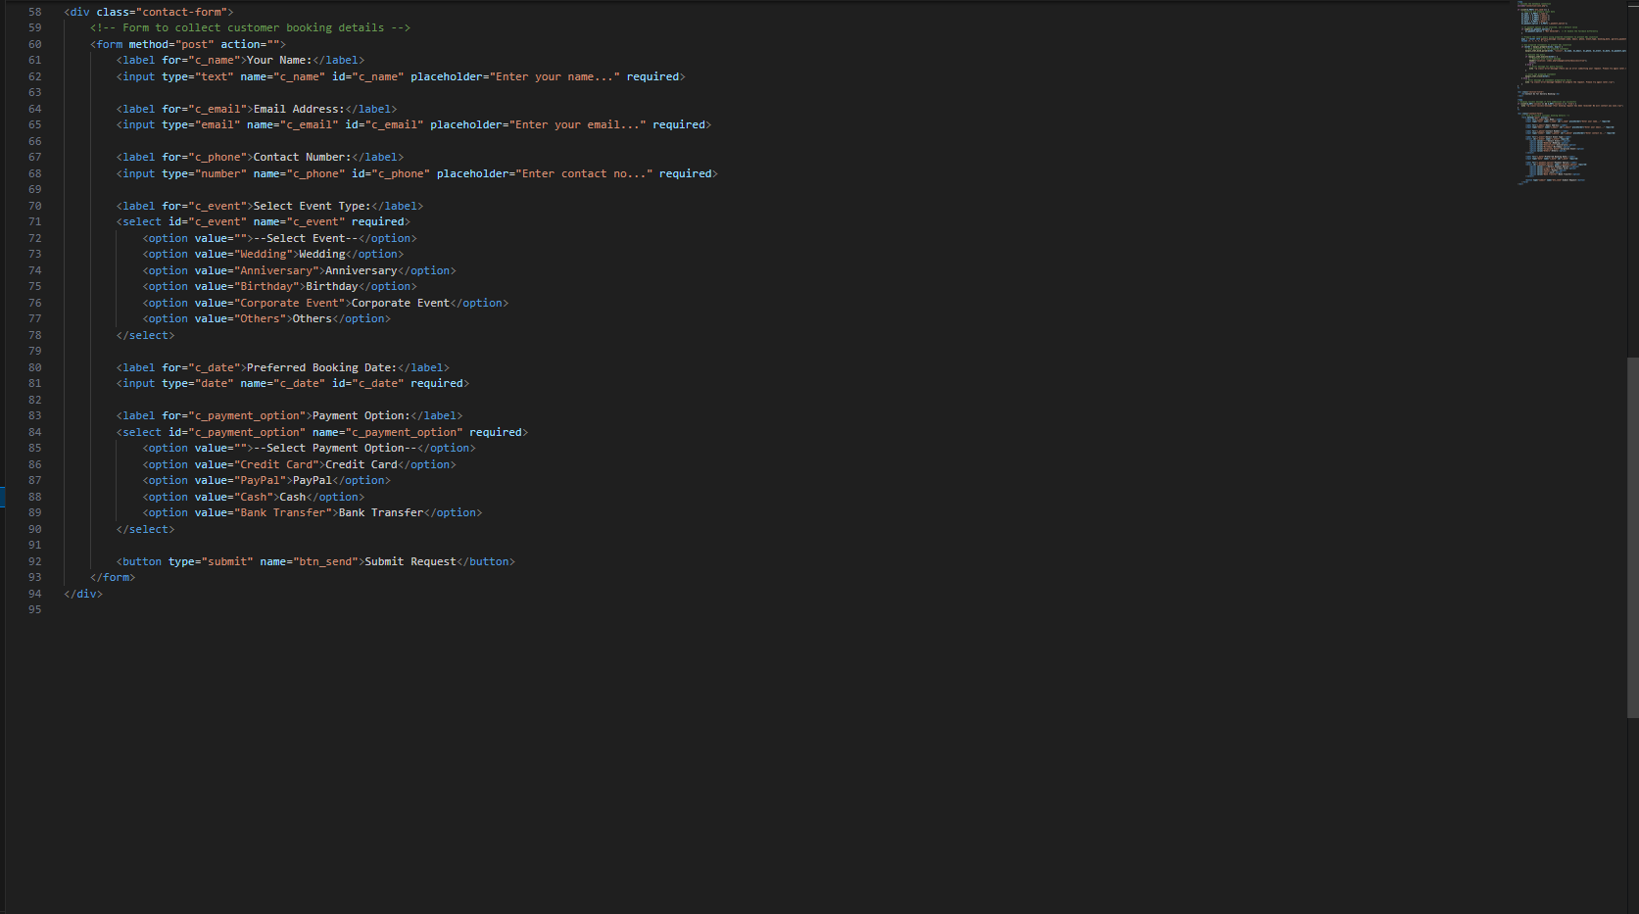
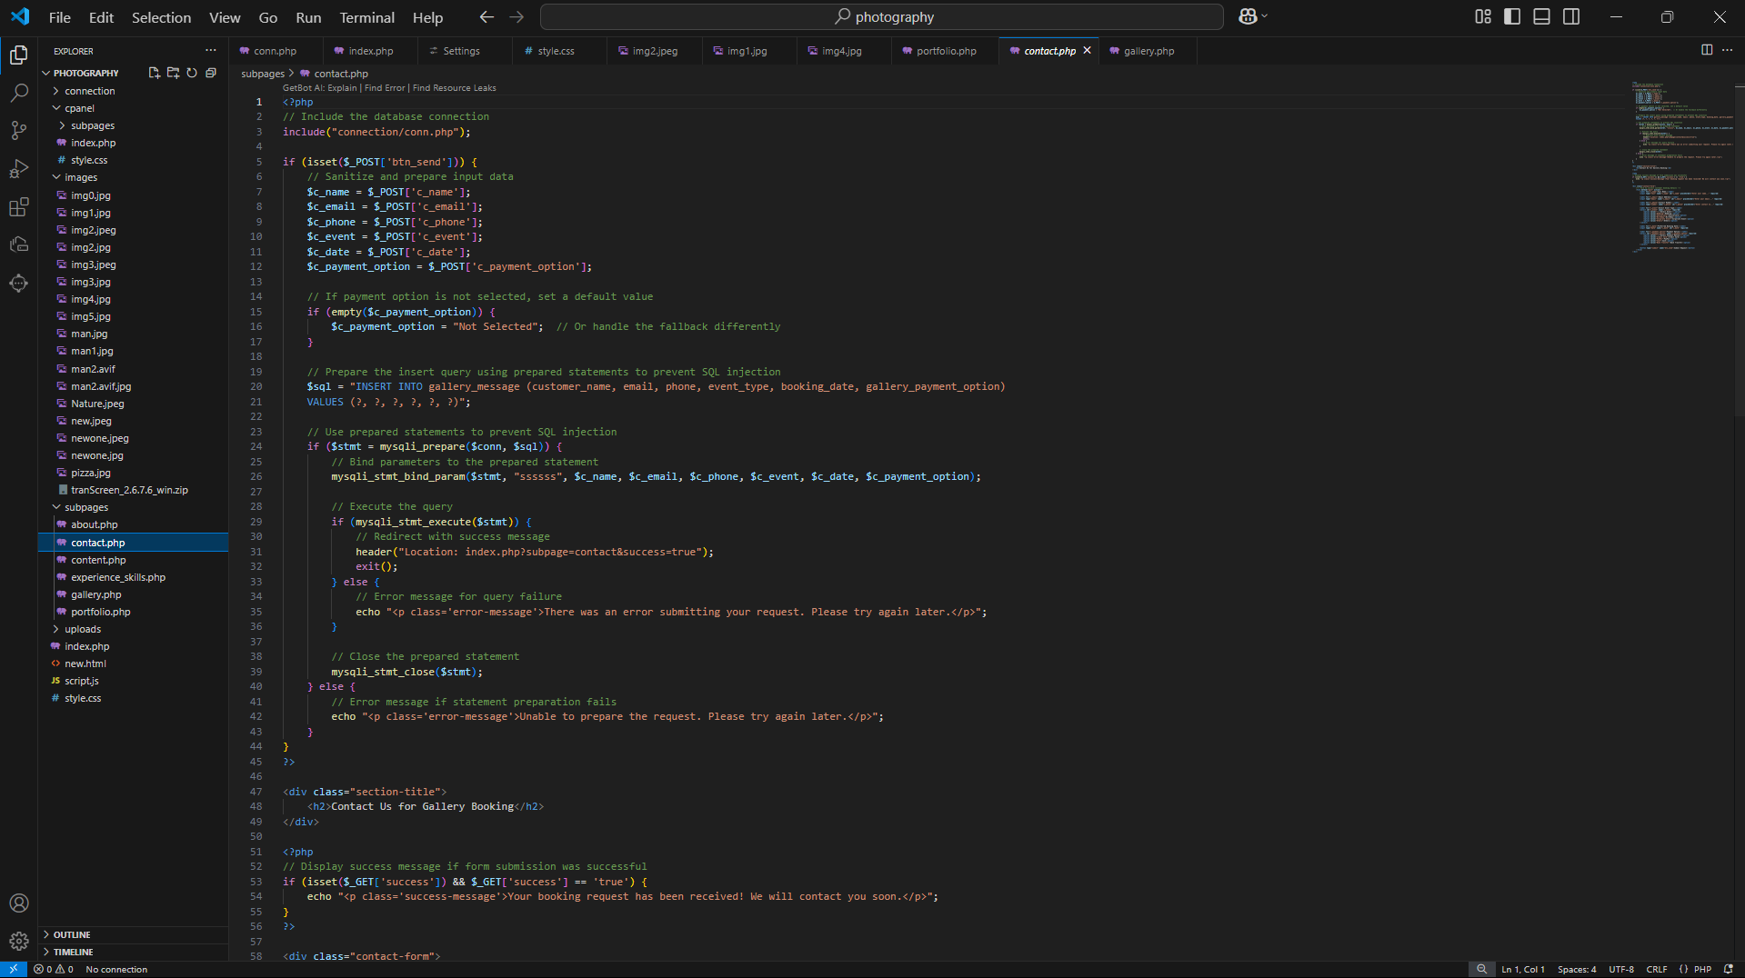
Code snipped of Contact Page:
Figure 14: Code snipped of Contact Page.

- Screenshot of cPanel Folder:
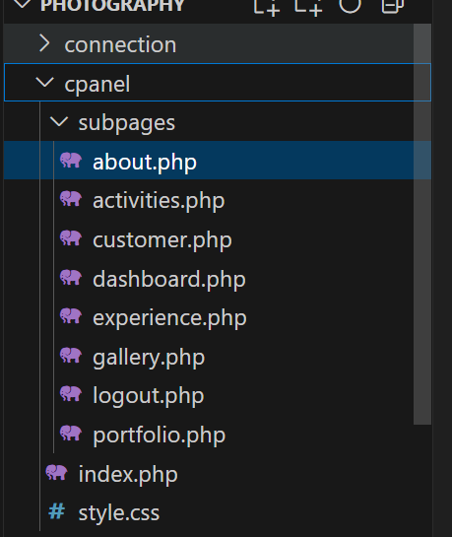
Figure 15: Screenshot of cPanel.
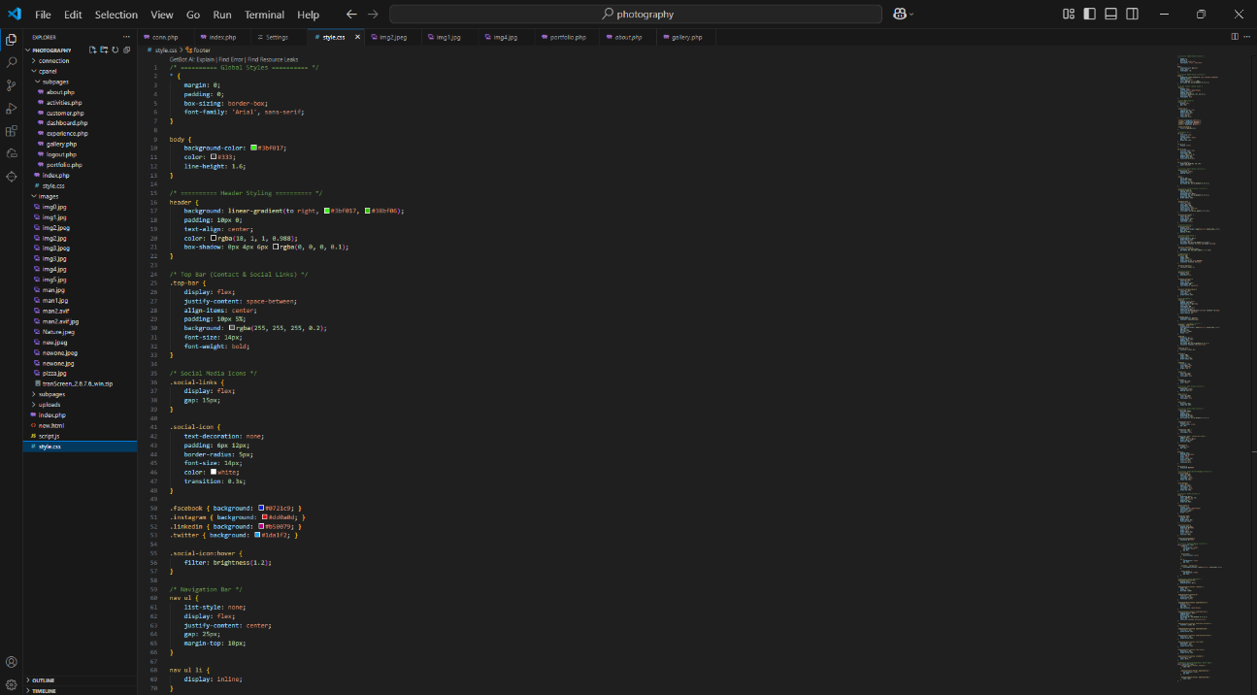
- Code snipped of Style.css:

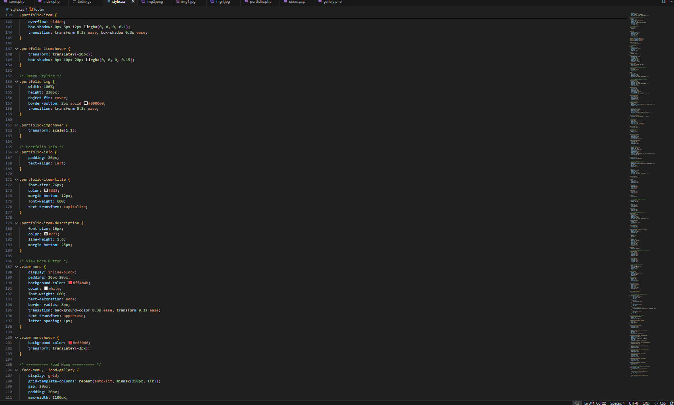
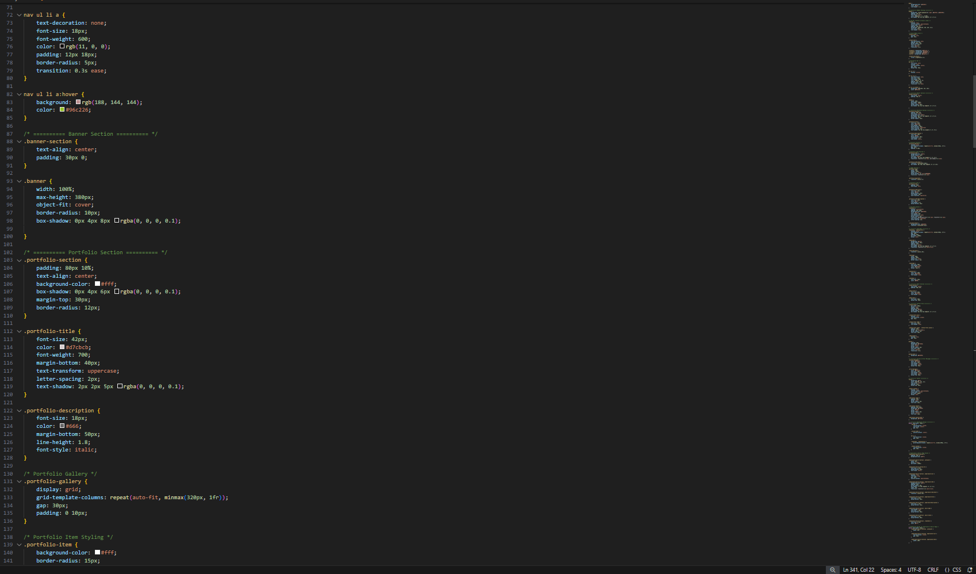

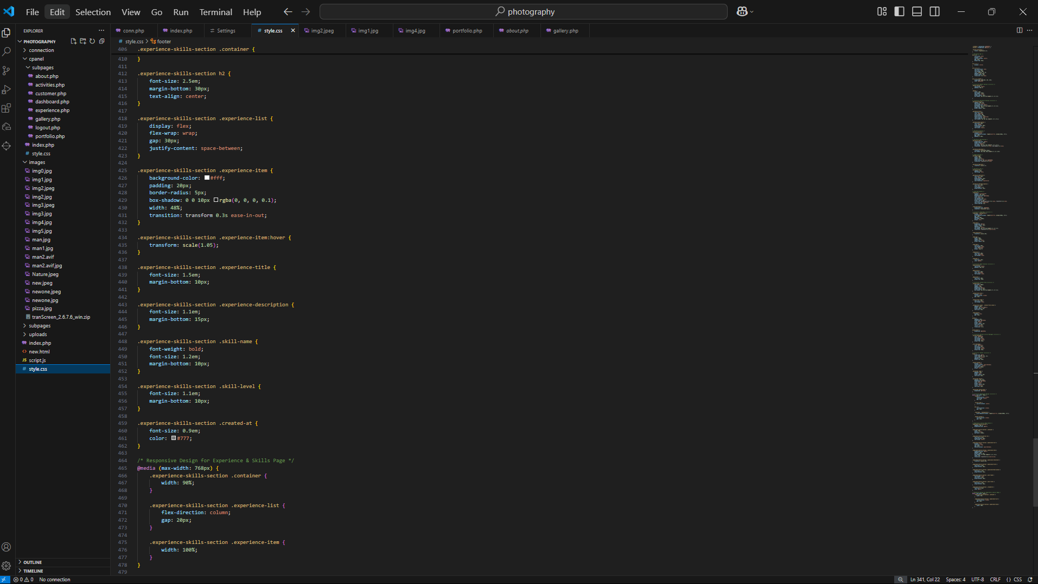
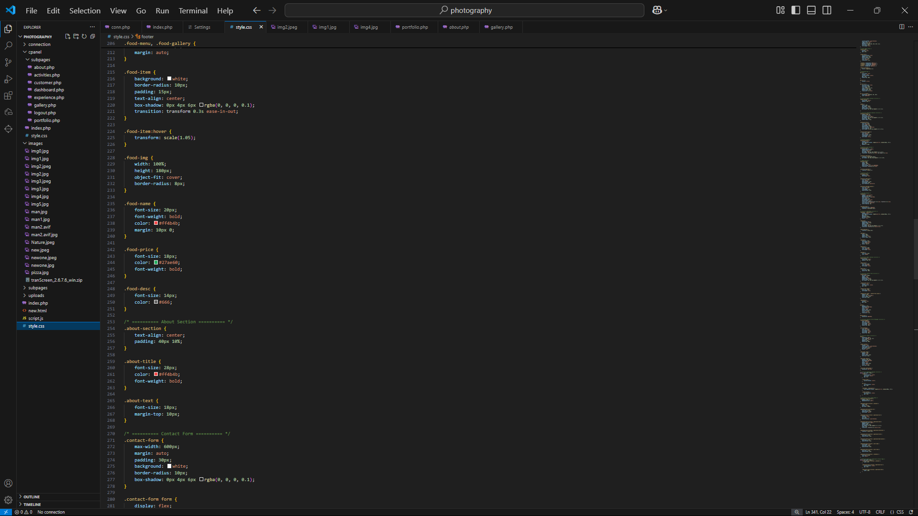
Figure 16: Code snipped of style.css.

Networking and Hosting Considerations
Sound hosting and networking are vital to secure, safe, and performing websites. A proper selection of hosting services and network configuration would help enhance the entire user experience and the performance of the website.

Networking
- Domain Name and DNS Configuration: The domain name should be registered, and DNS records (A, CNAME, MX) should be set correctly to produce a smooth access of the website.

- Security Measures: Strict observation of SSL certificates for HTTPS on the server is said to secure the communication, thus protecting the data.

- Bandwidth and Scalability: Bandwidth should be considered and also the scalability because more traffic means better chances of congestion and therefore sufficient bandwidth should be present, and a scalable solution should also be in consideration for upcoming expansions.

- Backup and Recovery: Backup and recovery mechanisms should be in place so that no data vanishes and business continuity is assured.

Hosting Conditions
Effective hosting service selection is a key to performance and security consistency. Common hosting solutions are:
- Shared Hosting: Suitable for small websites experiencing low traffic. It's cheap, though, limited in resources and control.

- Virtual Private Server (VPS): It offers dedicated resources and greater control than shared hosting but is still viable for medium-size projects.

- Dedicated Hosting: It provides the client with full control plus server resources, ideal for sites with heavy traffic and resource-hungry websites.

- Cloud Hosting: It offers high scalability and reliability, where resources are distributed across multiple servers. It is best for websites that are expected to see variable traffic.

Conclusion:
If networking and hosting are well-handled, the resulting overall conditions make sure that the website remains secure, quick, and available. A good secure and scalable hosting solution with SSL encryption and regular backups, recommended for Radiant Memories, is envisaged to provide a stellar experience for both the client and its users.

Security Features
Website security is an essential component of development, aimed at safeguarding data and ensuring the privacy of users while preventing unauthorized activity or attacks. By integrating strong security protocols, a website can protect itself and its visitors from potential risks (Williams, 2014). For the Radiant Memories website, the following security measures are crucial:
- SSL/TLS Encryption
- Facilitates secure data transmission between the server and users through encryption.
- Safeguards sensitive information such as user contact details and messages.
- Employs HTTPS to create a trusted connection with users.

- Regular Backups
- Stores copies of all website data to avert permanent loss due to server outages or cyber incidents.
- Provides quick recovery options and ensures continuity in services.

- Secure Authentication and Access Control
- Enforces strong password requirements along with multi-factor authentication (MFA) for administrative access to deter unauthorized entry.
- Implements role-based access control to limit entry into sensitive areas of the site.

- Firewall Protection
- Monitors incoming traffic, filtering out malicious activities such as Distributed Denial of Service (DDoS) assaults.

- Protection Against Common Vulnerabilities
- Regularly updates server software and plugins to avoid known vulnerabilities.
- Utilizes input validation along with secure coding methods to defend against SQL injection attacks and cross-site scripting (XSS).

- Malware Scanning and Monitoring
- Conducts periodic malware scans for early detection and removal of threats.
- Engages in real-time monitoring for unusual behavior, allowing prompt responses to any emerging threats.

Conclusion
Adopting these security strategies will help maintain a safe environment for both clients and users on the website. A proactive strategy toward web security is vital not only in protecting against ubiquitous threats but also in cultivating user trust in the platform's reliability.

Accessibility and Inclusivity Guidelines
Accessibility and inclusivity in designing websites are done with that final goal of the neutral experience for the users at all levels, up through those handicapped. Following accessibility guidelines ensures usability, ensures a level playing field with web standards such as WCAG, and brings about large-scale inclusivity and user-friendly operations for diverse audiences (Radanliev, 2024).

- Perceptible Content
- Create text alternatives that shall serve for any non-text content such as an image (alt text) to ensure a screen reader may be able to access.
- Use clear, clearly readable fonts with the text sufficiently contrasted against the background for better visibility.

- Operable User Interface
- The whole website should be navigable using both a keyboard and a mouse.
- Provide positive focus feedback to interactive components within a page-the buttons and links-to enhance navigation for users relying on assistive technology.
- Avoid content that may cause seizures, such as flashing animations.

- Understandable Information and Design
- All content should employ plain and simple language for clarity.
- Be consistent in the method of navigation as well as the design throughout the pages, with predictably pulsing somewhat.
- Provide instruction or labels for input fields on forms helping the users.

- Robust Compatibility
- Wide compatibility with a range of devices, browsers, and assistive technologies (Tian, 2014).
- The website was tested using screen readers and various assistive tools to discover and work on accessibility issues.

Conclusion
Putting all things into practice ensured not only that Radiant Memories was usable but that it was standards-compliant and would also provide user engagement for all. An inclusive design perspective increases the website reach and affirms its commitment to serve a multitude of audiences.

Implementation of a Multi-Page Website
The implementation phase is all about transforming design documents into a fully functional multi-page Radiant Memories website. This mainly consists of coding, feature integration, and checking to see that the website meets the requirements set by the client. A modern web technology stack was used in the development process of the website, in addition to other principles such as aesthetics, performance standards, and accessibility requirements (Szandala, 2024). Some of the key pages include portfolio, experience and skills, contact form, and admin panel for another content management process. Testing and quality assurance is undertaken to make sure that all items perform the functions expected, and are also secure and responsive across all devices.

Branded Multi-Page Website with Realistic Content
The multi-page website for Radiant Memories was built to represent the client's brand and create a first-class, attractive experience for visitors. The website has a structure containing multiple pages with timely content to call attention to the client's photography work and services.

Key Pages and Features
- Home Page: Welcoming introduction of the brand, a selected portfolio area, and contact or booking call-to-action button.
- Portfolio Page: A beautiful gallery where high-resolution images of past and ongoing photography projects appear with filtering and sorting options.
- Experience and Skills Page: An internal page where a short narrative of the photographer's skills, experience, awards, and accomplishments is highlighted.
- Contact Page: Contains a contact us template for user inquiry, together with the client's particulars to ensure direct contact.
- Admin Panel: Highly secured backend system to allow the client to manage items in the portfolio, edit content, and view client correspondence.

Design and Content Strategy
- Branding and Visuals: Color scheme and fonts have been meshed with the client's branding for a consistent and professional appearance.
- Realistic Content: Realistic content was cornered through meticulous research and genuine collection to maintain the services of this client, creating authenticity and relevance.
- Responsive design: The website is portable to mobile phones, tablets, and desktops for an efficient experience on any webpage.

Test Plan Creation
A test plan is imperative to guarantee that the multi-page website of Radiant Memories would function accordingly, meet user expectations, and be bug-free. The test plan elaborates on the specific areas to test against, forms of testing to apply, and success criteria such that problems can be highlighted for resolution before going live.
Objectives of the Test Plan
- To verify that the website functions correctly in all pages and features.
- To ensure proper operation on various devices and browsers.
- To test for performance, security, and responsiveness.
- To detect and fix usability issues with the aim of enhancing user experience.

Key Areas for Testing
- Functionality Testing
- Checking whether all links, buttons, and forms work correctly.
- To check the content management functions of the admin panel, such as adding, editing, and deleting content.
- To check whether messages sent via the contact form are received.

- Compatibility Testing
- To check the responsiveness of the website on various devices (desktops, tablets, mobiles).
- To check the compatibility with major browsers like Chrome, Firefox, Safari, and Edge.

- Performance Testing
- To check page load times and ensure the speed of response.
- To find any bottlenecks in performance.

- Security Testing
- Verify that SSL-Encryption (HTTPS) is active.
- Check for vulnerabilities such as SQL Injection, Cross-site scripting (XSS), and unauthorized access.

- UI and UX Testing
- Check that all pages share the same design mechanisms and concepts and that they are intuitive to users.
- Check for ease of navigation and accessibility compliance.

Testing Techniques
- Manual Testing: Used to validate UI/UX and perform functionality checks.
- Automated Testing: Used for repetitive operations, like performance and security testing.

Success criteria
- All functionalities are working without errors.
- The website works responsively; it is compatible across devices and browsers.
- Performance criteria such as load times and response speed are acceptable.
- No critical security vulnerabilities have been found.

Implementation of Test Plan
The implementation of the test plan is a basic phase that establishes if the multi-page website for Radiant Memories stands up to the qualifying standards for functionality, performance, compatibility, and security. The process includes performing the defined test cases, working on the results, and fixing issues arising during the course of testing (Pyhäjärvi, 2004).

Testing Process
The testing process followed a methodical approach dealing with key areas of the test plan:
- Functionality Testing
- All navigation links, buttons, and forms were tested to ensure their functionality.
- Content management functionality of the admin panel was tested for flawless creation, editing, and deletion of portfolio items.
- Correctness for message submission and receipt with the contact form.

- Compatibility Testing
- Making sure that the website is fully responsive on all device types such as desktops, tablets, and smartphones.
- Testing mainstream browser candidates, including Chrome, Firefox, Safari, and Edge.

- Performance Testing
- Page load times were measured to ascertain whether or not the web page would work quickly and efficiently.
- In addition, slow page elements have been determined and correspondingly optimized to ensure greater speed.

- Security Testing
- The SSC certificate was also checked for communication secure (HTTPS).
- The usual vulnerabilities such as SQL injection, XSS, and unauthorized entries were checked and tested for.

- User Interface (UI) and User Experience (UX) Testing
- Ensured design and layout consistency across all pages.
- Reviewed the website's ease of navigation and overall users' experience.

Test Results and Resolutions of Issues
- Most of them passed, further validating the website's functionality and compatibility.
- Minor issues, such as misalignments on mobile devices and slow-loading images, were reported and resolved without delay.
- Test for security didn't detect any major vulnerability, therefore security's position is strong.

Quality Assurance and Evaluation
Quality assurance (QA) and evaluation are significant stages in the website development process to ensure that the final product satisfies the necessary quality assurance regulations, performance aspects, and user experience. QA classification includes systematic monitoring and testing of the website in identifying and fixing errors, while the evaluation considers reviewing the entire design and development process. This process ensures that the website is trustworthy, safe, and completely fulfilling client requirements and user expectations.

Web Design Principles, Standards, and Guidelines
Observe web design principles, standards, and guidelines when creating user-based, accessible, and industry-standard websites. These principles ensure an excellent user experience and maintain functionality and consistency across different devices and platforms.
Key Web Design Principles:
- User-Centered Design (UCD)
Design of a website with a focus on user needs and expectations; whereby simplicity and usability in navigation and interfaces are prioritized.
- Consistency
Constructs and frames uniform layout, color scheme, and typography throughout all pages to represent a coherent flow of user experience, hence preventing easy confusion with better usability throughout.
- Visual Hierarchy
Organizing content so that the user’s attention is drawn to the more important elements. It employs size, color, and spacing to construct a clear hierarchy of content.
- Mobile Responsiveness
The website's ability to grow or shrink to fit any device or screen. More user-friendly for mobile and tablet devices.
- Accessibility
Provides the WCAG compliance to let people with disabilities use the website. The presence of alt text in images, keyboard navigation, contrast ratios suffice.

Web Design Standards and Guidelines
- HTML5 and CSS3 Standards: Ensuring modern coding practices for making semantic, maintainable, and efficient code.
- SEO Best Practices: Use-on page elements and optimize tags, descriptions, and URLs to enable visibility on search engines.
- Cross-Browser Compatibility: Ensure a website works well on all the major browsers (Chrome, Firefox, Safari, and Edge).
- Security Guidelines: Every website dedicated to its user and, more importantly, its content, implements secure authentication, SSL encryption, and regular updates to protect the website and its users.

Conclusion
The improved design initiated by realizing web standards and guidelines will help build a high-quality website that's functional, secure, and accessible. For Radiant Memories, the application of best practices helps assure a positive, balanced user experience coupled with consistency on technical and design aspects.

Quality Assurance Process
This ensures that the multi-page website for Radiant Memories meets the expected standards concerning functionality, security, performance, and user experience (Maia, 2006). QA is generally an ongoing process during the design and development phases that will detect and fix errors in a reliable and high-level product.
Steps in the Quality Assurance Process
- Requirement Analysis
- Understanding the client's desires and needs through a proper analysis in order to define major quality benchmarks.
- Providing specific, measurable criteria for functionality, performance, and design.

- Test Plan Development
- Development of an exhaustive test plan that incorporates all aspects of the website, including functionality, compatibility, security, and performance.
- Defining the test cases and success criteria for each feature of the test plan.
- Testing and Validation
- Functionality Testing: Testing all features of the website- navigation, forms, and admin panel.
- Compatibility Testing: Ensuring that the website is compatible with most devices and browsers.
- Performance Testing: Testing the page load time and working on slow loading page components.
- Security Testing: Testing the website for any vulnerabilities and additional security measures to protect it from common threats or attacks.
- UI/UX Testing: Testing the website to ensure smooth, continuous, accessible, and user-friendly experiences.

- Bug Tracking and Resolution
- Registering the issues and bugs discovered while testing.
- Prioritizing and solving the bug reports before moving to the next stage.

- Final Review and Approval
- Final review to verify that all issues are addressed and corrections are made, and ascertain that the website meets all required standards.
- Client approval prior to deployment.

Tools Used in Quality Assurance
- Manual Testing: For user interface and functional validation.
- Automated Tools: For performance, security, and compatibility testing (Lighthouse for performance audits, OWASP ZAP for security testing).

Conclusion
Quality Assurance is the process used to confirm that Radiant Memories meets functional, secure, and user-friendly standards. The testing and validation of each and every piece through the QA process have worked to lower the error rate in the end product and elevate its quality to provide one that is dependable.

Evaluation of Design and Development Process
Evaluating the design and development process is essential for understanding how effectively the multi-page website for Radiant Memories meets its original goals and fulfills client expectations. This evaluation showcases strengths, identifies challenges, and outlines improvements made during the project, thus ensuring valuable lessons can be utilized in future endeavors.

Design Process Evaluation
The design stage concentrated on creating an engaging, user-friendly, and visually attractive website.
- Strengths:
- The employment of wireframes along with interface designs contributed to an organized layout.
- Following web design principles guaranteed consistency, accessibility, and ease of use.
- Authentic content and effective branding elements bolstered the site’s professional look.

- Challenges:
- Achieving seamless mobile responsiveness across different devices necessitated several revisions and extensive testing.
- Striking a balance between aesthetic appeal and performance optimization proved challenging, especially for pages laden with images.

Development Process Evaluation
During the development phase, efforts were directed toward converting the established designs into a working multi-page website utilizing contemporary web technologies.
- Strengths
- Adopting responsive design strategies ensured that functionality remained consistent across various devices and browsers.
- The inclusion of an admin panel presented an intuitive content management system that simplified operations for clients.
- Security measures such as SSL encryption alongside input validation safeguarded data integrity.

- Challenges:
- Significant effort was required in performance enhancement to achieve reduced page loading times.
- Troubleshooting compatibility issues with older browser versions extended development timelines considerably.

Improvements and Lessons Learned
- Enhanced Planning and Testing: Introducing automated testing tools earlier might have lessened debugging responsibilities later on.
- Image Optimization: Leveraging advanced image compression techniques enabled quicker load times while maintaining quality standards.
- User Feedback Integration: Collecting user feedback at earlier stages would potentially accelerate recognition of usability enhancements.

Conclusion
The process undertaken to develop the Radiant Memories website yielded many learning opportunities. Despite facing some obstacles throughout this journey, ultimately, the project achieved its goal by delivering a high-quality, agile, and secure online presence. Consistent evaluation accompanied by ongoing improvements played a crucial role in ensuring that the final result satisfied client expectations comprehensively.

Technical Challenges and Solutions
The multi-page website for Radiant Memories possessed numerous technical impediments during its design and development phases. Solving those problems required a lot of tactical thinking, analytical problem-solving, and implementation of appropriate solutions to deliver the product that satisfied set standards.
- Challenge: Mobile Responsiveness
- Description: The website's compatibility and usability across different devices (desktops, tablets, smartphones) was a tough call, mainly because of the hefty image pages.
- Solution: To develop an international website, responsive design principles were applied through flexible grids, CSS3 media queries, and scalable images. About three rounds of testing were done on all devices to ensure consistent performance and layout.

- Challenge: Slow Page Load Times
- Description: The initial slower page load times came mainly from large images and unoptimized content and adversely affected the user experience.
- Solution: Advanced compression tools were used to compress the images. Lazy-loading techniques were applied to prioritize loading the pertinent contents first.

- Challenge: Cross-Browser Compatibility
- Description: Cross-browser compatibility displayed obscure layout in older versions of browsers due to improper layout functionality and absence of features.
- Solution: Cross-browser testing was applied when polyfills were to be utilized, ensuring cross-browser compatibility since the earliest versions. The problems were solved by applying standard code to the page, including fallback options for features unsupported.

- Challenge: Security Vulnerabilities
- Description: Common vulnerabilities discovered were SQL injection, cross-site scripting (XSS), and insecure data transmission.
- Solution: SSL encryption for secure communication via HTTPS was introduced, input validation, and sanitization were enforced to mitigate common attacks. Server software and plugin updates were performed regularly.

- Challenge: Admin Panel Usability
- Description: Feedback indicated that the admin panel was not very intuitive for non-technical users.
- Solution: The admin panel was made more user-friendly with the use of tooltips, clear labels for buttons, and guided instructions for the non-tech supplying demographics.
- Additional testing was done, along with client feedback to finalize the designs.

Testing and Performance Review
Effective functionality of the multi-page website for Radiant Memories depends on testing alongside performance reviews to create a smooth user experience. Testing evaluates all website elements to verify functionality and security as well as compatibility and performance standards. The testing process identifies problems to optimize site speed along with reliability and usability features which work across all browsers and devices.

Overview of test plan
Tasted tasks: Welcome to the photography
Tested by: Client Tested date : 10th Feb

S.N | Expected date | Real output | Remarks
1. | 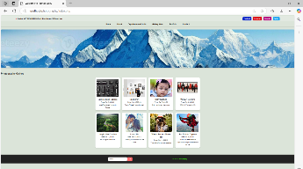  Index page | 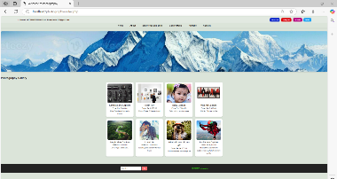 | Success
2. | About page:  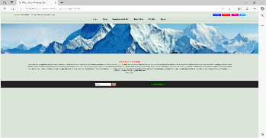 | 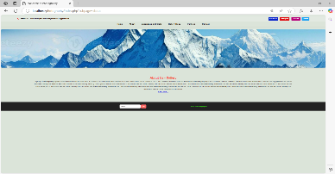 | Success
3. | Experience and skills:  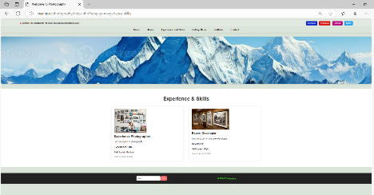 | 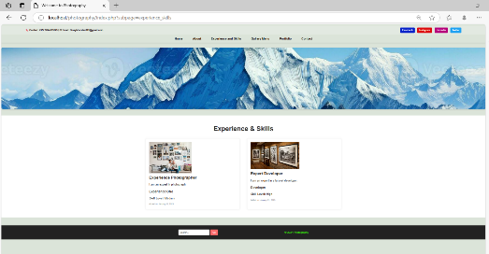 | Success
4. | Gallery page:  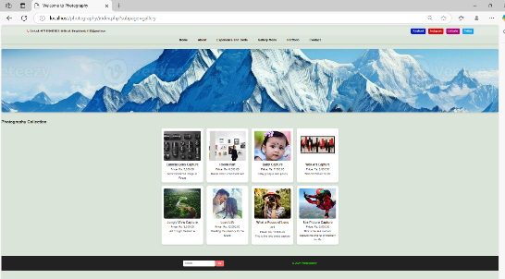 | 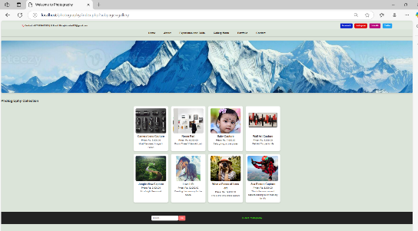 | Success
5. | Portfolio Page:  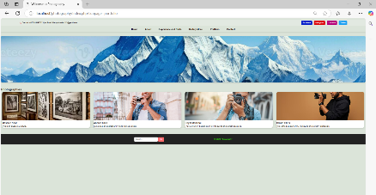 |  | Success

Test Plan Results
Testing of the Radiant Memories website followed the prepared test plan to validate its function ability alongside performance and compatibility and security measures. Website quality assessment revealed essential findings which led to the detection of necessary areas for improvement.
- Functionality Testing
Objective: The goal of this stage remains to validate that every function operates according to design specifications.
Results:
- The navigation system and buttons together with forms operated without any detected malfunctions.
- Admin panel features enabled effortless management of portfolio contents through item addition and editing and deletion processes.
- Users could submit contact form messages that resulted in successful transmission and generated correct email confirmations.

- Compatibility Testing
Objective: This objective aims to check the site’s performance when used on a variety of mobile devices and web browsers.
Results:
- The site displayed proper formatting for all devices starting from desktops through tablets to smartphones.
- Testing established the website's functionality on all major browser platforms that included Safari, Chrome, Firefox and Edge. The testing process solved all minor problems that existed in earlier versions.
- Performance Testing
Objective: The testing aims to measure page load times together with the detection of bottlenecks.
Results:
- The page load times improved to less than 3 seconds through implementing compression for images as well as lazy loading methods.
- The website performed without any performance constraints during the conducted stress testing.
- Security Testing
Objective: The goal of this test was to identify security vulnerabilities as well as validate website security measures.
Results:
- The website used SSL encryption to provide safe communication through HTTPS.
- A thorough analysis showed that the website contained no fatal security defects including SQL injection, XSS or unauthorized access.
- Security examination of the website generated no major detection of vulnerabilities so it successfully completed all security testing.

Recommendations for Improvement
The functional and design requirements of Radiant Memories website have been achieved while additional optimization could lead to increased performance together with enhanced user experience and better scalability (MD, 2013). The following suggestions will optimize the website performance to its fullest extent.

- Performance Optimization
- The website can benefit from employing advanced caching methods that cut down server strain while optimizing page loading speed.
- The delivery of content should go through a Content Delivery Network (CDN) which provides fast content delivery especially to global users.

- Advanced SEO Practices
- The website can achieve better search results by optimizing its meta tags alongside headings and image alt descriptions.
- Structured data schemas should be integrated into websites because they enhance search engine rankings.

- Accessibility Enhancements
- The system must allow users to access pages using keyboard shortcuts.
- System users who have vision difficulties can modify font size and contrast levels through an available accessibility option.

- Security Improvements
- The company should perform systematic security checks to identify emerging security risks.
- Two-factor authentication (2FA) must be enabled through the admin panel because it produces better security protection.

- User Feedback and Analytics
- Users will benefit from Google Analytics by enabling the organization to track their activities and make improvements continuously.
- Users should provide feedback persistently to help identify necessary improvements in the system.

Conclusion
The creation of Radiant Memories multi-page website consisted of full-fledged stages which included design development alongside implementation phases followed by testing and evaluation work needed to provide a secure visual platform which conformed with client demands. Through its pages the website demonstrates both the client's work portfolio and their abilities and provides users with an easy-to-use interface. A final product that follows present-day web design criteria along with optimization practices also maintains accessibility standards achieves both cross-browser and device compatibility as well as security reliability. The project solved issues related to mobile adaptation and load times and safety through effective solutions. The website met all deployment criteria because the testing regime successfully found and removed critical problems. The website will maintain its relevance through future improvements that result from user feedback. The web development project provided practical learning opportunities in which the client received successful completion of their technical and design specifications.

References
Anon., n.d.
Antonini Macedo, A. d. L. B., 2000. Two-level domain decomposition methods with Lagrange multipliers for the fast iterative solution of acoustic scattering problems. Computer Methods in Applied Mechanics and Engineering, 184(2-4), pp. 213-239.
Artto, K., 2016. From the front end of projects to the back end of operations: Managing projects for value creation throughout the system lifecycle. International Journal of Project Management, 34(2), pp. 258-270.
Bonastre, O. M., 2019. Origins of the Domain Name System. IEEE Annals of the History, 41(2), pp. 48-60.
Bridges, M., 2014. The Website Design and Usability of US Academic and Public Libraries: Findings from a Nationwide Study. JSTOR, 53(3), pp. 253-265.
Coull, S. E., 2012. Understanding domain registration abuses. Computers & Security, 31(7), pp. 806-815.
Cüneyt Bayılmış, Ü. Ç., 2022. A survey on communication protocols and performance evaluations for Internet of Things. Digital Communications and Networks, 8(6), pp. 1094-1104.
Maia, M. C., 2006. Quality assurance requirements in produce processing. Trends in Food Science & Technology, 17(8), pp. 406-411.
Marrison, C., 2015. Understanding the threats to DNS and how to secure it. Network Security, 2015(10), pp. 8-10.
MD, D. A. G., 2013. Recommendations for Evaluation of Health Care Improvement Initiatives. Academic Pediatrics, 13(6), pp. 523-530.
MD, M. S. F., 2001. Empowering radiologie education on the internet: A new virtual website technology for hosting interactive educational content on the world wide web. Journal of Digital Imaging, Volume 14, pp. 113-116.
Morgan, P. T., 2019. Road cycle TT performance: Relationship to the power-duration model and association with FTP. Journal of Sports Sciences, 37(8), pp. 902-910.
Offutt, J., 2009. Modeling presentation layers of web applications for testing. Software & Systems Modeling, 9(1), pp. 257-280.
Pyhäjärvi, M., 2004. Integrating Testing and Implementation into Development. Engineering Management Journal, 16(1), pp. 33-39.
Radanliev, P., 2024. Accessibility and inclusiveness of new information and communication technologies for disabled users and content creators in the Metaverse. Disability and Rehabilitation, 19(5), pp. 1849-1863.
Renesse, R. V., 1985. Distributed operating systems. Assocation for computing Machinery, 17(4), pp. 419-470.
Rizvi, A., 2023. Defending Root DNS Servers against DDoS Using Layered Defenses (Extended). Ad Hoc Networks, Volume 151.
Szandala, T., 2024. Enhancing SEO in Single-Page Web Applications in Contrast With Multi-Page Applications. IEEE, Volume 12, pp. 11597-11614.
Tian, X., 2014. Asymptotically Compatible Schemes and Applications to Robust Discretization of Nonlocal Models. SIAM Journal on Numerical Analysis, 52(4).
Vaidyanathan, K., 2006. Analysis of Software Aging in a Web Server. IEEE, 55(3), pp. 411-420.
Varley, P. A., 2010. A new algorithm for finding faces in wireframes. Computer-Aided Design, 42(4), pp. 279-309.
Williams, C., 2014. Unclonable security features for additive manufacturing. Additive Manufacturing, 1-4(3), pp. 24-31.
Yanan, C. & Zhaoxin, Z., 2023. Configuration anormaly detection and resolution risk assessment of authoritative domain name server. Computers & Security, Volume 135.

